* **Lab Task 3:**

Display the plane ID and model of planes that belong to airports in 'Asia'.

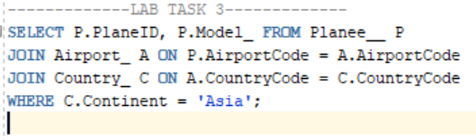

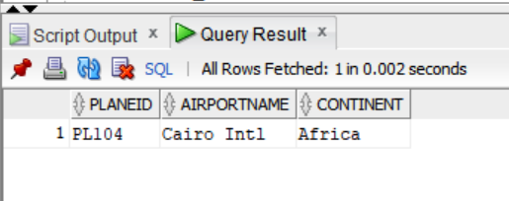OUTPUT: